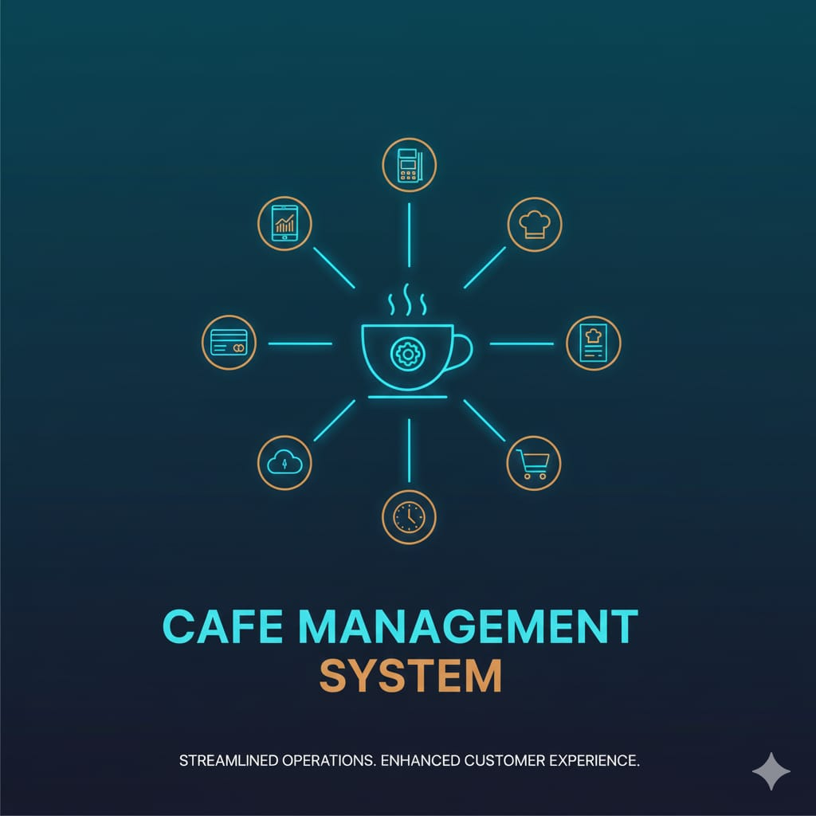

NAME: DIVYANSHI MOHANTY
COURSE NAME: INTRODUCTION TO PROBLEM SOLVING AND PROGRAMMING USING PYTHON
COURSE CODE: CSE1021
REGISTRATION NUMBER: 25BCE10828
PROJECT NAME: CAFÉ MANAGEMENT SYSTEM USING PYTHON
INDEX
- PROBLEM STATEMENT
- PROJECT SYNOPSIS
- FUNCTIONAL REQUIREMENT
- NON-FUNCTIONAL REQUIREMENT
- SYSTEM ARCHITECTURE
- DESIGN DIAGRAMS
- DESIGN DECISIONS AND WORKFLOW
- IMPLEMENTATION AND DETAILS
- RESULT SCREENSHOT
- TESTING APPROACH
- CHALLENGES FACED
- LEARNINGS AND KEY TAKEAWAYS
- FUTURE ENHANCEMENTS
- REFERENCES

- PROBLEM STATEMENT

Customers visiting a restaurant should be able to view the menu, place an order, and receive the correct bill instantly. The current manual process can be slow and error-prone.
This project aims to create a simple Python-based ordering system where the user can:

- View the menu
- Place one or two orders
- Apply a discount coupon (if available)
- Get the final bill
- The system also restricts invalid orders (e.g., ordering only coffee is not allowed).

2. PROJECT SYNOPSIS

This is a console-based Restaurant Billing System developed using Python.
It uses a predefined menu stored in a dictionary and interacts with the customer through the input() function. The program calculates bills, applies discounts using coupon codes, and prints the final total amount. Conditional statements handle different billing scenarios.

3. FUNCTIONAL REQUIREMENTS

1. Display Menu: The system must show all available food items and prices.
2. Take Customer Order: User should enter the item name they want to order.
3. Check Order Validity:
If the user orders only coffee, it should show an error.
4. Additional Order Option: User should be able to order a second item.
5. Bill Calculation:
Add prices of ordered items.
Apply discount if coupon “Sihab” is used.
6. Display Final Bill: Show the total amount with or without discount.
7. Exit Message: Print a thank-you message at the end.

4. NON-FUNCTIONAL REQUIREMENTS

1. Usability:
Simple text-based interface.
Easy to understand instructions.
2. Performance:
Program must respond instantly to user inputs.
3. Reliability:
Accurate billing.
Correct handling of missing or invalid inputs (item not in menu, invalid coupon).
4. Maintainability:
Simple Python code, easy to modify and extend.
5. Portability:
Can run on any system with Python installed.
5. SYSTEM ARCHITECTURE

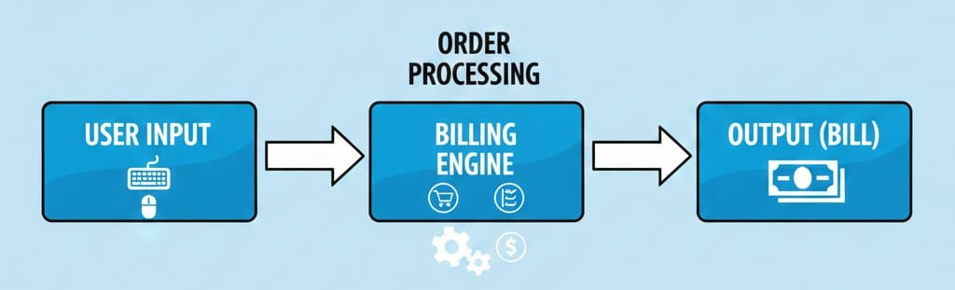

Architecture Layers:-
- Interface Layer: input(), print().
- Logic Layer: conditions for order, discount application.
- Data Layer: menu dictionary storing food items and prices.
6.DESIGN DIAGRAMS

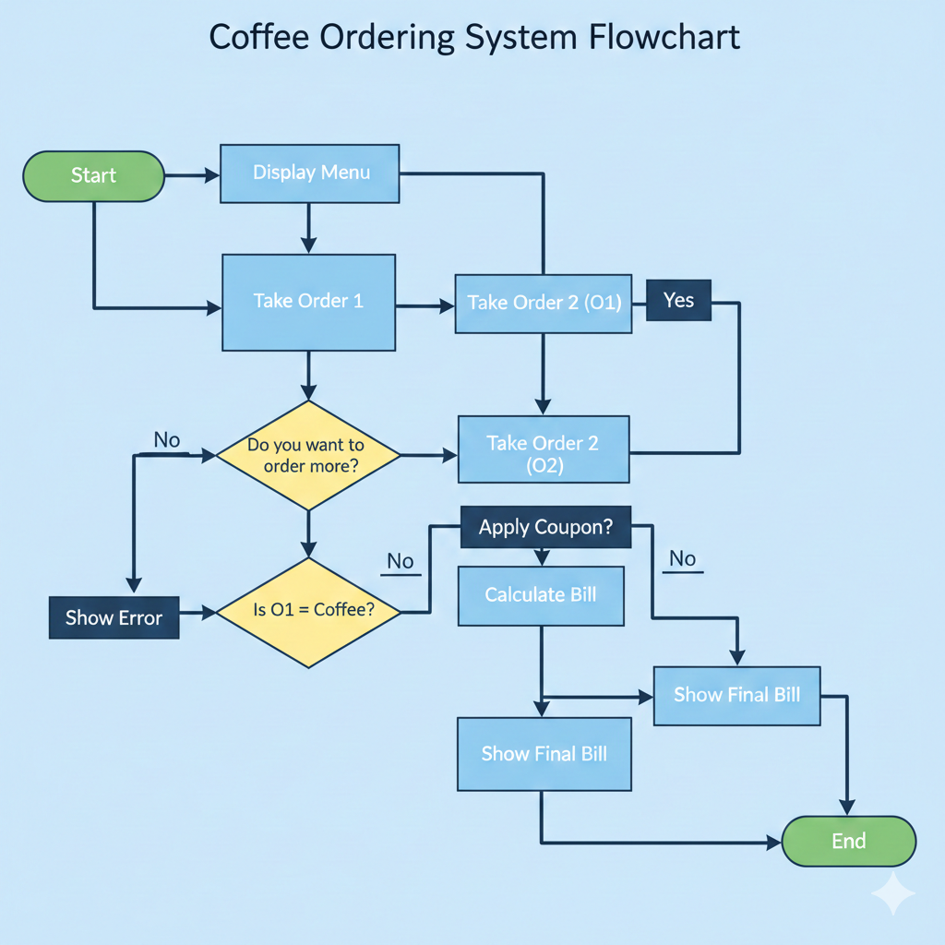
7. DESIGN DECISIONS & WORKFLOW

1. Dictionary for Menu: Using a Python dictionary allows O(1) access to item prices.
2. If-Else Conditions:
• To check whether only "Coffee" is ordered.
• To handle coupon logic.
3. Sequential Workflow:
The program follows a simple linear flow to maintain clarity.
4. Coupon Stored in Menu:
"Sihab": 0.2 is stored like other menu items for convenience.

8. IMPLEMENTATION AND DETAILS

Key Components:-
- Menu Dictionary: 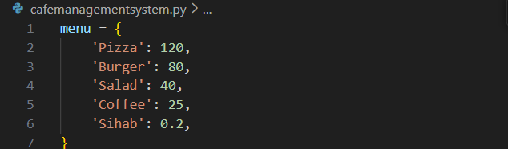

- Order Input: Order1 = input("What do you want to order? : ")
- Validation: Coffee-only order is invalid
- Coupon Logic:
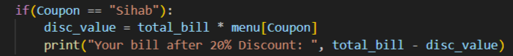

- Output: Prints bill or error messages.
9. RESULT SCREENSHOT

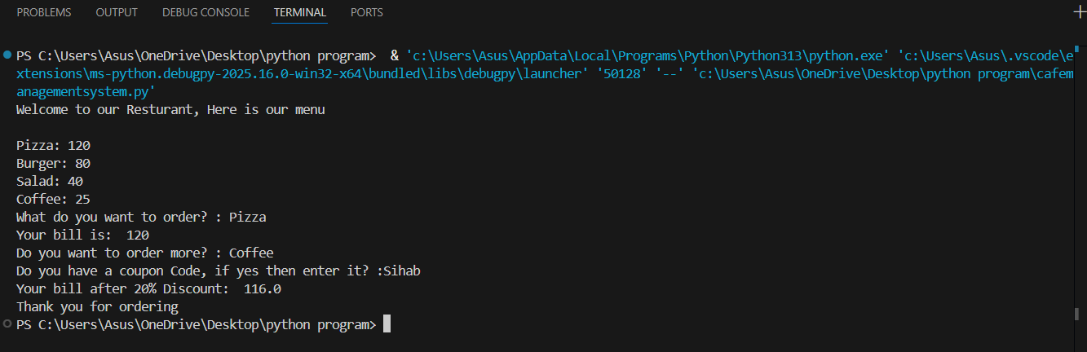

10. TESTING APPROACH

Test Cases Performed:-
Test Case | Input
Ordering Pizza Only | Pizza-no
Ordering Coffee Only | Coffee-no
Two Valid Orders | Pizza->Yes->Burger
Valid coupons | Coupon = Sihab
Invalid coupon | Random Code

Testing Method:
- Manual testing with different combinations.
- Checking behavior for valid & invalid inputs.

11. CHALLENGES FACED
- Ensuring that user cannot order only coffee.
- Handling invalid coupon codes gracefully.
- Avoiding program crash when user enters an item not in the menu (not handled yet).
- Managing multiple conditional scenarios.

12. LEARNINGS & KEY TAKEAWAYS

- How to use Python dictionaries effectively.
- Taking user input and applying conditional logic.
- Basic billing system implementation.
- Understanding discount calculations.
- Importance of input validation for real applications.

13. FUTURE ENHANCEMENTS

1. Add support for multiple items (more than two).
2. Add input validation:
- Prevent program crash if user enters unknown dish name.
3. Add quantities (e.g., 2 pizzas).
4. Implement a graphical user interface (GUI).
5. Add database support for menu updates.
6. Improve coupon system with expiry dates or multiple discount types.

14. REFERENCES

1. Python Official Documentation https://docs.python.org
2. Basic Python Tutorials (variables, dictionaries, conditions).
3. Online resources and classroom notes on Python programming.

